MD2201: Data Science

Name of the student: SUMIT UMBARE Roll No. 77

Div: IT-B Batch: B3

Date of performance: 01/02/2024

Experiment No.1

Title: Laboratory on Data Visualization
Aim: i. To explore the dataset for different case study examples with different commands.
ii. To plot the Box plot and scatter plot.

Software used: Programming language R.

Code Statement:
- Write a single R code to display the answers for the following questions.
Case Study: Consider the “pollutant” data set.

- What is the mean of “Temp” when “Month” is equal to 6?
- How many observations are there in the given data?
- Print last two rows of the data.
- What is the value of Ozone in 47th row?
- How many values are missing in Ozone column?
- What is the mean of Ozone column excluding missing values?
- Extract the subset of rows of the data frame where Ozone values are above 31 and Temp values are above 90. What is the mean of Solar.R in this subset?
- What was the maximum ozone value in the month of May (i.e. Month is equal to 5)?

- Write a single R code to display the answers the following questions

Case Study: Hair Eye color Data set

- How many people have brown eye color?
- How many people have Blonde hair?
- How many Brown haired people have Black eyes?
- What is the percentage of people with Green eyes?
- What percentage of people have red hair and Blue eyes?

- Write a single R code to display the answers for the following questions

Case study: Germination Data Set

- What is the average number of seeds germinated for the uncovered boxes with level of watering equal to 4?
- What is the median value of the germinated seeds for the data covered boxes?

Establish conclusions on the basis of available data and write them in the conclusion part.
a. Association of levels of watering with the number of germinating seeds in case of covered boxes as well as uncovered boxes.
b. Association of number of germinating seeds with the fact that the boxes were covered or uncovered.

- Write a single R code :
- To display the Boxplot for sepal length of iris data set as shown below
- To display the Scatter plot for murders data set present in “dslabs” package as shown below.

Give proper title, x,y axis label etc. to each plot.

Expected Boxplot:
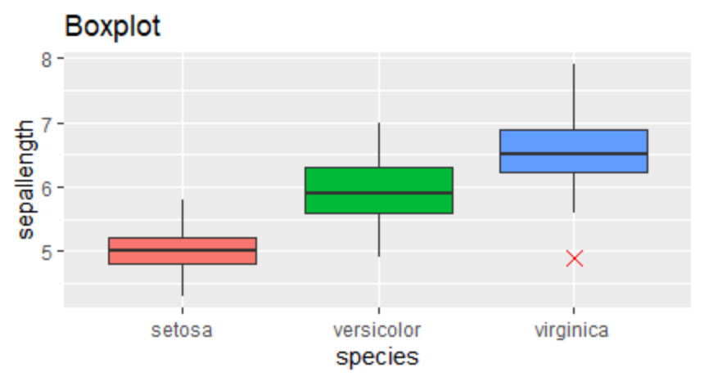

Expected Scatter Plot:
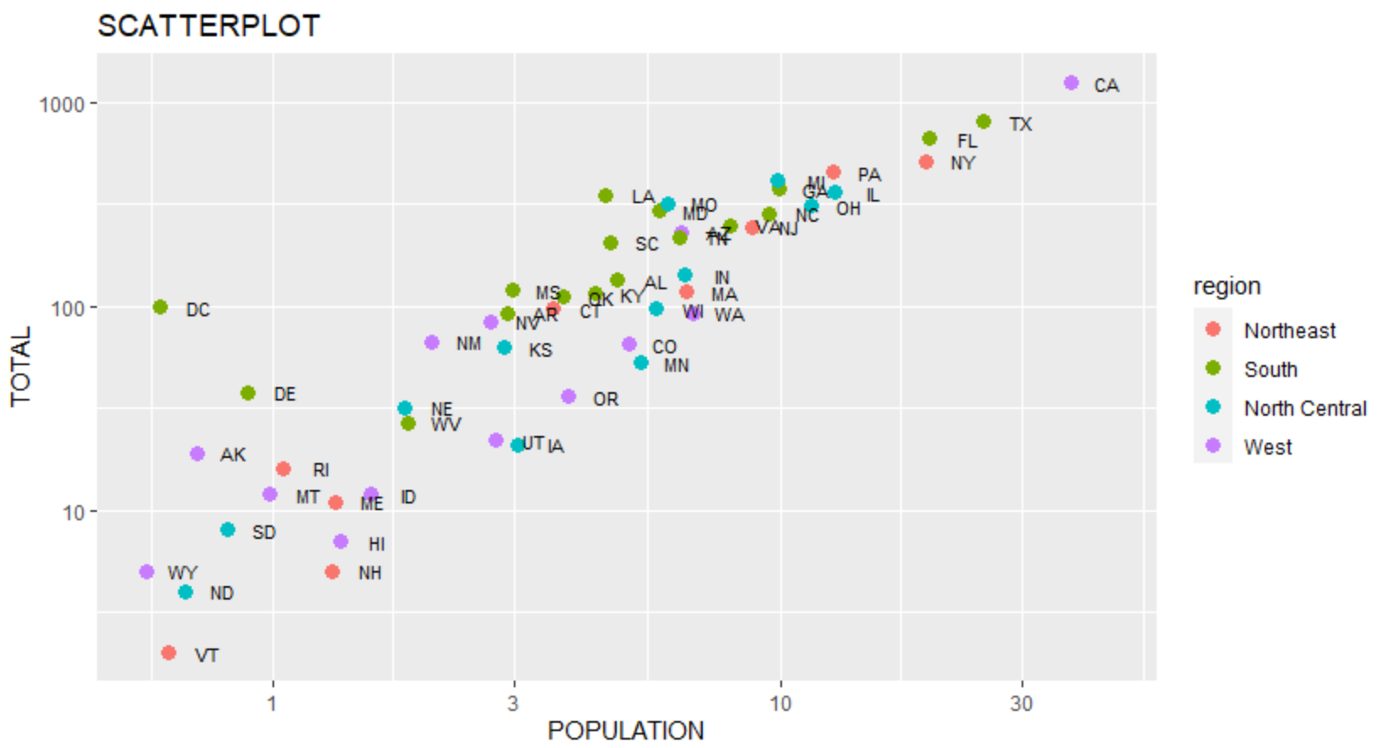
Code: (Write code for all above cases here)
#Pollutant Dataset----
cat("\nPollutant Dataset :")
f<-read.csv("pollutant_csv.csv")
m<-mean(f$Temp[f$Month==6])
cat("\nMean Of Temprature When Month Is 6 : ",m)
n<-nrow(f)
cat("\nNo of Observation in Dataset :",n)

cat("\nLast two rows of the data \n")
last<-tail(f,2)
print(last)

o<-f$Ozone[47]
cat("\n47th Value of Ozone is :",o)

ms<- sum(is.na(f$Ozone))
cat("\nNumber values are missing in Ozone column : ",ms)

m1<-mean(f$Ozone,na.rm = T)
cat("\nThe mean of Ozone column excluding missing values : ",m1)

m2<-mean(f$Solar.R[f$Ozone>31 & f$Temp>90],na.rm=T)
cat("\nThe mean of Solar.R in subset when where Ozone> 31 and Temp > 90 : ",m1)

mx<-max(f$Ozone[f$Month==5],na.rm=t)
cat("\nThe maximum ozone value in the month of May ",mx)

#Hair Eye color Data set ----
cat("\n\nHair Eye color Data set OUTPUT :")

g<-read.csv("hair_eye_color_csv.csv")
nBrown<-sum(g$Hair.Color=="Brown")
cat("\nNumberof people have brown eye color =",nBrown)

nBlonde<-sum(g$Hair.Color=="Blonde")
cat("\nNumberof people have Blonde Hair color =",nBlonde)

nBB<-sum(g$Hair.Color=="Brown" & g$Eye.Color=="Black")
cat("\nNumberof Brown haired people have Black eyes=",nBB)

green<-sum(g$Eye.Color=="Green")
allColors<-length(g$Eye.Color)
percent<-(green/allColors)*100
percent

red<-nrow(subset(g,Hair.Color=="Red" & Eye.Color=="Blue"))
percentage<-red*100/nrow(g)
cat("\nThe percentage of people have red hair and Blue eyes", percentage)

#Germination Dataset ----
cat("\n\nGermination Dataset OUTPUT :")
h=read.csv("germination_csv.csv")
a2<-subset(h,Box=="Uncovered" & water_amt==4)
avg<-mean(a2$germinated)
cat("\nAverage no of seeds germinated for uncovered boxes & watering equal to 4 :",avg)

germinated=h$germinated
covered<-subset(h,Box=="Covered",select=germinated)
med<-median(covered$germinated)
cat("\nThe median value of the germinated seeds for the data covered boxes: ",med)

par(mfrow=c(1,2))
Covered<-subset(h,Box=="Covered")
Uncovered<-subset(h,Box=="Uncovered")
plot(Covered$water_amt,Covered$germinated,col="Green",pch=16,xlab="Water amount",ylab="Seeds germinated",main="For Covered Box")
plot(Uncovered$water_amt,Uncovered$germinated,col="Green",pch=16,xlab="Water amount",ylab="Seeds germinated",main="For Uncovered Box")

par(mfrow=c(1,2))
hist(Covered$germinated,label=T)
hist(Uncovered$germinated,label=T)

#iris Dataset ----
p<-ggplot(iris,aes(Sepal.Length,Species,fill=Species))+geom_boxplot(outlier.size = 4,outlier.colour = "red",outlier.shape =4)+theme(legend.position = "none")+labs(title="BOXPLOT")+coord_flip()

#dslabs Dataset
library(dslabs)
library(ggplot2)

data(murders)
ggplot(murders, aes(x = population/10^6, y = total, color = region)) +
geom_point() +
scale_x_log10(labels = scales::comma_format()) +
scale_y_log10(labels = scales::comma_format()) +
labs(x = "Population in millions (log scale)",
y = "Total murders (log scale)",
title = "US Gun Murders in 2010")

Results:

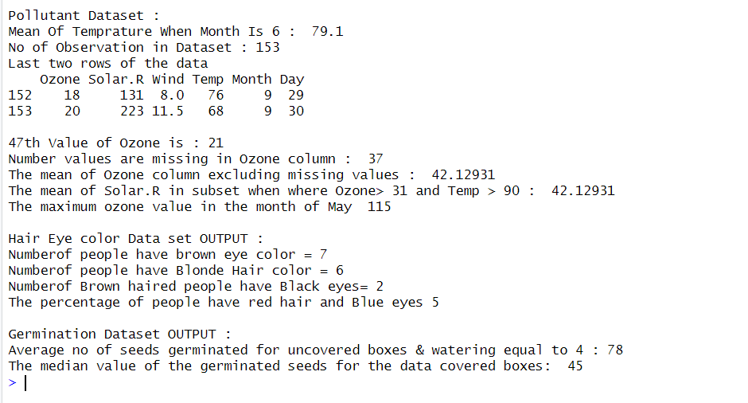
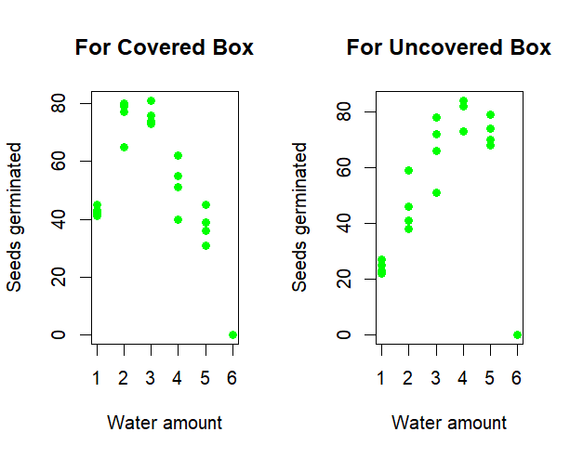

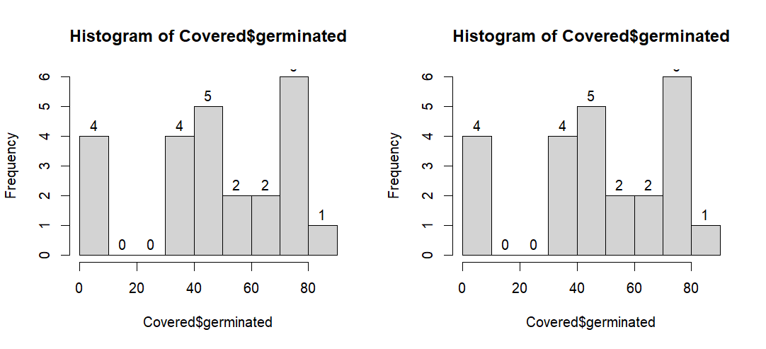

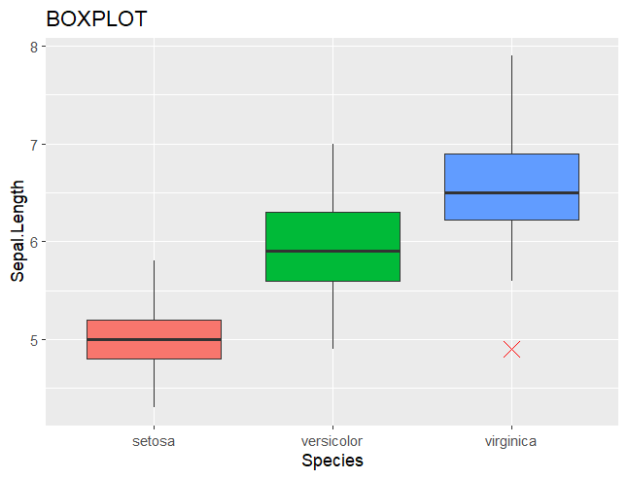

‘

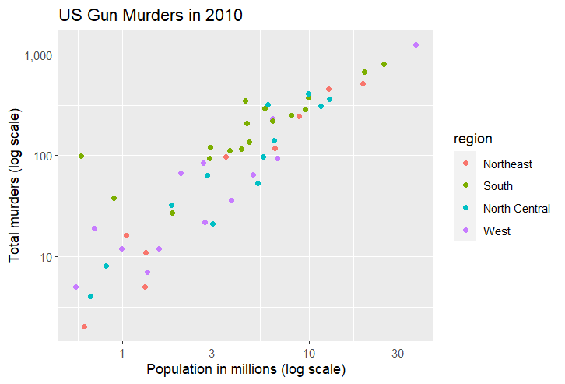

Conclusion:

In this experiment, we conducted a comprehensive analysis of various datasets to explore different aspects of data manipulation and visualization techniques.We began by examining the Pollutant Dataset, where we computed statistical summaries such as mean temperature, counted observations, and investigated missing values. Subsequently, we delved into the Hair Eye Color Dataset, analyzing categorical distributions and computing percentages based on specific hair and eye colors. Moving forward, the Germination Dataset offered insights into agricultural studies, where we calculated averages and medians of germinated seeds, accompanied by graphical representations.Moreover, the Iris Dataset provided an opportunity to visualize the distribution of a continuous variable using a boxplot. Finally, the exploration of the Murders Dataset involved creating a scatter plot with ggplot2 to investigate the relationship between population size and the total number of murders, categorized by regions.Throughout this experiment, we employed various R functions and packages to manipulate, summarize, and visualize the datasets, gaining valuable insights into different analytical techniques and methodologies

